Final Project Proposal

D00251774

Nishant Verma

**Student Name: Student ID:**

Analysis and Prediction of Stocks Data

**Project Title:**

1. Background Research / Problem Description (200 words max)

*Explain the title and application of your work. Detail the problem(s) you are trying to solve, your proposed solution, and the techniques you will use. Give details of any similar studies, and how your study will differ from these.*

My project title is quite self-explanatory i.e., to analyze and visualize how the stock prices varies from day to day, week to week, month to month and so. Multiple stock can also be compared to evaluate the growth of the company. The main objective of the project is to develop a model that can beat the market and allow us to make statistically informed trades. Stock market is highly influenced by the public and private news and these news are the triggers to change in stock prices. However, understanding and identification of the pattern in stocks prices could provide a winning edge to the trader/investor and help them making an informed decision. I’d mostly be using python and many other technologies which I’d feel necessary to achieve my goal.

1. List the research questions related to the problem statement. Subsequently list out your project goals.

* Which market and which company to target for the project?
* Do I have to use single company’s stocks data or multiple company’s stocks data for the project?
* How to find or collect the data?
* Is the data safe to use for the project or is it ethically right to use the data?
* What technologies and methodologies to be used for the project?
* How to check the validity of the final model?

1. Data description, tools and software, references, link to data sources and ethics consideration.

So far, I have been able to find a dataset for the project- 6 years of stocks data of S&P 500 companies having the following attributes:

* Date – Date of the day
* Open – Price of the stock at market open
* High – Highest price reached on that particular day
* Low Close – Lowest price reached on that particular day
* Volume – Number of shares traded
* Name – Stock’s ticker name

It would be too soon to name the tools and software to be used for the project. I would be able to mention the same in further progress reports.

Link to the data: <https://www.kaggle.com/camnugent/sandp500?select=all_stocks_5yr.csv>

The data is publicly available and is approved for use in any independent study or project.

1. Gantt Chart

On the next page – I’d suggest to save the image and then read it by zooming in.

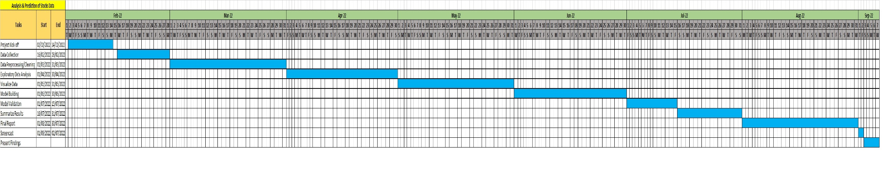

1. Special requirements and deliverables of the project

I might need to learn or to do few courses outside the curriculum but can’t be stated at this stage. I’d mention about the same in the following progress reports.

I’d be delivering a model which would be able to predict the price of the stock to a certain degree.

1. Risks – What risks can you identify? What will be the impact if the risk becomes a reality? What can you do to minimize the impact?

* Contingency plan in case you do not meet your project goals – prioritize the goals.
* Unexpected output – any output – you should report it.
* Loss of data/coding due to system failure – work on cloud/back up your work.
* System compatibility – look for virtual machine options.
* Ethics risks – work under the ethical guidelines detailed on DKIT/ Data protection website.